## Mobile App Development

Mobile app development is the process of creating software applications specifically designed to run on mobile devices such as smartphones and tablets. These apps are developed to provide users with various functionalities and serve different purposes, ranging from entertainment and social networking to productivity and e-commerce.

## Types of Mobile Applications

There are three kinds of mobile applications. They are;

* Native apps.
* Web apps.
* Hybrid apps.

### Native Apps

Native app development serves a single operating system or platform. And they use a programming language that’s specific to that platform or operating system. This is usually a choice of iOS, Android, or Windows Phone.

Native apps run straight from devices. As a result, they can support strong performance, high levels of security, and advanced features ‘native’ to the specific operating system. Some of the common programming languages seen across the three operating systems for different types of mobile apps include the following;

* **iOS:** Programming languages include **Swift, Python, and Objective-C**
* **Android**: Programming languages include **Kotlin and Java**
* **Windows Phone:** Programming languages include **C# and .NET**

#### Native subcategories: cross-platform development

The single biggest challenge of the native approach is **unreusable code**. Developers need to create another set of code to fit another operating system, to replicate the app. However, there is a way around this, and it supports different types of mobile apps, in the form of **cross-platform development**: *the process of creating software applications that can run on multiple operating systems (like iOS and Android) using a single codebase*. And one of the more popular cross-platform-based frameworks is React Native, which is an open-source UI framework that offers a high level of flexibility. React Native uses a Javascript library. And, it sits alongside other cross-platform frameworks such as Flutter, Ionic, and Xamarin as a native app-building alternative that enables cross-platform development. In practice, code used to develop an app for a specific OS, for example, Android, becomes reusable for iOS and Windows Phone.

#### Examples and Use Cases of Native Apps

Some popular exemplifications of native mobile apps include Spotify, Telegram, WhatsApp, Snapchat, etc. Native apps are ideal for operations that bear high performance, access to device features, and platform-specific stoner gests. These can include gaming apps, social networking platforms, and productivity tools.

#### Advantages of Native Apps

* Access to device-specific features
* No internet connection needed
* Impressive users experience on Android or IOS

#### Disadvantages of Native Apps

* Multiple code bases
* Higher budget costs
* Longer build times
* Maintenance can be complicated
* Native apps tend to be less discoverable than hybrid or web apps

### Web Apps

Web apps are types of mobile apps that draw from web-based technologies. They do not require installation, making them accessible to anyone with a web browser. However, they may lack some of the native functionality and offline capabilities found in native apps. However, their internet-enabled nature gives them added flexibility and a more responsive design that can work on any mobile device or operating system.

Web apps run off a single codebase and use languages such as **HTML5, CSS, Javascript, and Ruby**. They also use server-side languages or web application frameworks of the developer’s choice such as PHP, Rails or Python.

#### Web app subcategory: Progressive Web Apps

PWAs are web apps that provide a native app like experience. These are designed and developed similar to web apps. These apps take support of services workers. These are published on play store or app store.

Some super examples of revolutionary internet apps consist of Pinterest, Starbucks, Adidas, Tinder, Trivago etc.

#### Examples and Use Cases of Web Apps

Some famous examples of web-based cellular apps are; Amazon, Canva, Netflix, Walmart etc. Web apps are appropriate for conditions the place cross-platform compatibility and convenient accessibility are important, such as information portals, on-line buying platforms, and content-based applications.

#### Advantages of Web Apps

* Easy discoverability
* Faster development time than Native
* Simple to Maintain
* Lower development costs
* They work on all Platforms
* Updates made to the application are immediately available

#### Disadvantages of Web Apps

* Slower performance than native
* Unable to work offline
* Cannot access platform features
* Unable to access UI and match style like native apps

### Hybrid Apps

Of all the different types of mobile apps, a hybrid app is a combination of a native app and a web app. In practice, it’s developed as a web app in a native app container. By leveraging certain native platform features and device hardware, hybrid apps offer the benefits of a native experience while flexing to non-native environments. But to drive this type of cross-platform functionality, hybrid apps make use of front-end development technologies like JavaScript, HTML5, Ionic, Cordova and CSS.

#### Examples and Use Cases

Popular examples of hybrid apps encompass Facebook, Gmail, Instagram, LinkedIn, Twitter, Slack, and Evernote. Hybrid apps are appropriate for initiatives that require a quicker improvement cycle and want to attain a wider target audience throughout specialplatforms. They are frequently used for content-centric applications, commercial enterprise tools, and utility apps.

#### Advantages of Hybrid Apps

* Less expensive to sell in app store
* simple to maintain
* Lower development costs
* Targets multiple platforms
* Allows apps to match look of native application and take advantage of the platform's UI style

#### Disadvantages of Hybrid Apps

* Slower performance than native
* Can't access platform features dues to WebView restrictions

## 2. Mobile Application FrameWorks

### 2.1. React Native

React Native is one of the most recommended Mobile App Frameworks in the development industry. The framework, created by Facebook, is an open-source framework that offers you to develop mobile applications for Android & iOS platforms. The React Native framework is based on React and JavaScript that aims to develop native applications over hybrid applications that run on a web view. Moreover, it is a cross-platform development framework that uses a single code base for both Android & iOS applications. Some of the major benefits of React Native are mentioned below:

* Code Re-usability & Cost-Effective
* Compatible with third-party plugins
* Re-usable components for optimal performance
* Provides hot deployment features
* Ease of Maintenance

There are various renowned mobile applications built with React Native such as Instagram, Soundcloud, Uber Eats, and many more.

### 2.2. Flutter

Flutter, developed by Google, is a UI toolkit to build native applications for mobile apps, desktop and web platforms. Flutter is a cross-platform mobile app development framework that works on one code base to develop Android as well as iOS applications. The framework provides a large range of fully customizable widgets that helps to build native applications in a shorter span. Some of the major benefits of Flutter are mentioned below:

* Provides Full Native Performance
* Flexible User interface (UI)
* Provides Strong Widget Support
* Offers Built-in Material Design
* Fast Application Development

Some of the major mobile applications that are built on Flutter are; Google Ads, Hamilton, SpaceX Go, Watermaniac, and various others.

### 2.3. Ionic

Ionic, developed in 2013, is an open-source framework that allows you to build cross-platform for mobile apps using web technologies like HTML, CSS & JavaScript. The application built through the Ionic framework can work on Android, iOS & Windows platforms. The framework offers numerous default UI components such as forms, action sheets, filters, navigation menus, and many more for attractive and worthwhile design. Moreover, Ionic has its own command-line interface and various other in-built features such as Ionic Native, Cordova-Based App packages, etc. Some of the major benefits of Ionic for mobile development apps are mentioned below:

* Faster Application Development
* Availability of Cordova Plugins
* Built-in UI components
* Platform Independent
* Based on AngularJS

### 2.4. Xamarin

Xamarin is also one of the most popular open-source frameworks used to develop mobile applications. The framework, acquired by **Microsoft**, is based on **.Net** and allows you to build native applications for Android, iOS, and Windows platforms. Xamarin comes with almost every required tool and library needed to build native applications and offers you to create rich experiences using native UI elements. Moreover, Xamarin also supports the feature of sharing the common codebase to make the development process more efficient and cost-effective. There are various benefits of Xamarin, some of these are mentioned below:

* Native API Access & UI Support
* Easier API Integration
* Target All Platforms
* Cost-Effective & Faster Development Process.

### 2.5. Mobile Angular UI

Mobile Angular UI is an open-source mobile application development framework that merges the implementation of the Bootstrap and Angular frameworks. The framework offers various UI components such as overlays, switches, sidebars, navbars, scrollable areas, etc. to provide robust and attractive user interfaces for the applications. Furthermore, Mobile Angular UI supports fastclick.js and overthrow.js to create rich experiences. Moreover, Mobile Angular UI supports cross-browser compatibility that allows it to automatic handling JavaScript code for each browser. Some of the major benefits of Mobile Angular UI for mobile development apps are mentioned below:

* Responsive Framework
* Offers Interactive Components
* Easier conversion from the web or desktop application to the mobile app

### 2.6. Apache Cordova

Apache Cordova, previously marketed as PhoneGap, is a popular developer-friendly application development framework. PhoneGap, purchased by Adobe Systems in 2011, is an open-source framework that allows you to build cross-platform mobile apps using CSS3, HTML5, and JavaScript. The Cordova plugins allow programmers to utilize smartphone hardware features such as GPS, cameras, and accelerometer to offer a native-like interface. Apache Cordova’s prominent characteristics are a quicker production approach with a single code plus third-party application administration tool.

Features of PhoneGap:

* A single source of code
* App management methods from third parties
* Compatibility with all the platforms.

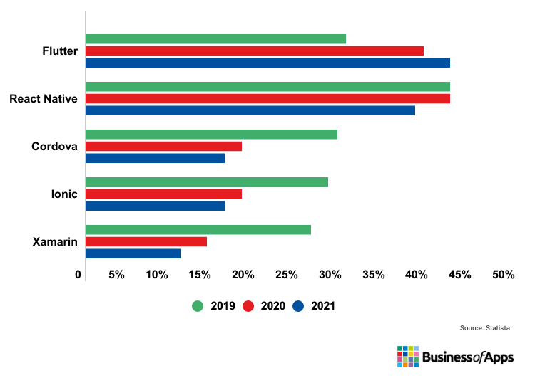

*Fig: Chart showing the percentage of use of the most popular frameworks*

## Some FAQs for Mobile App Development Frameworks

1***. Which mobile app development framework should I learn in 2025?***

All the above-mentioned mobile applications frameworks (React Native, Flutter, Ionic, Xamarin, Apache Cordova, including Swiftic, and jQuery Mobile) are essential for any mobile app developer to learn.

***2. Which are the easy-to-use mobile app development frameworks?***

jQuery Mobile is simple to understand and also uses an open-source framework. It enables programmers to create native-looking Android, iOS, and desktop applications utilizing popular online standards like HTML5, JavaScript, or CSS3.

***3. Which mobile app development frameworks can be used for cross-platform app development?***

React Native, Ionic Framework, Xamarin, NativeScript, Adobe PhoneGap, and Flutter are the best mobile app development frameworks for cross-platform app development.

***4. Which frameworks are the best for native app development?***

Native Script is an accessible framework that uses Angular, Typescript, JavaScript, and CSS to develop native mobile applications. React Native is the finest JavaScript framework for creating native apps for any platform and operating system. Xamarin is among the most used mobile app development frameworks. Microsoft launched this native framework.

***5. Which is the best mobile app development framework?***

* Flutter is the most popular Android framework out there. It has speedily scaled the list of dominant positions after being recognized as the most-used framework second by React Native.
* React Native is among the most commonly utilized mobile applications frameworks, with 42% of programmers globally using it. It was created by Facebook and is built on JavaScript. Using Android and iOS platforms, React Native programmers can quickly construct a smartphone application with a native appearance and touch.

## References

1. Types Of Mobile Applications:

<https://www.businessofapps.com/app-developers/research/types-of-mobile-apps/>

<https://www.geeksforgeeks.org/types-of-mobile-application-appium/>

<https://medium.com/@olivereric075/what-are-the-types-of-mobile-apps-d625b01e7fb0>

1. Mobile Application Frameworks:

<https://www.geeksforgeeks.org/top-mobile-app-development-frameworks/>

<https://technostacks.com/blog/mobile-app-development-frameworks/>